Contents
Create Azure OpenAI Resource and Deploy Models 2
Create Azure OpenAI Resource 2
Deploy GPT Model 2
Deploy Embedding Model 2
Get Key and Endpoint 2
Setup Local Virtual Python Environment 3

Create Azure OpenAI Resource and Deploy Models

Create Azure OpenAI Resource
- Azure portal
- Search for Azure OpenAI
- Create
- Region: Sweden central (swedencentral)

Deploy GPT Model
- On the Overview page of Azure OpenAI resource
- Select Explore Foundry Portal / Go to Foundry Portal
- Model catalog
- Search for: gpt-4o-mini
- Deploy / Use this model
- Global Standard
- Deploy

Deploy Embedding Model
- Model catalog
- Search for: text-embedding-3-small
- Deploy / Use this model
- Global Standard
- Deploy

Get Key and Endpoint
On Azure OpenAI page,
- Resource Management
- Keys and Endpoint
- Copy Key 1 (and paste somewhere)
- Copy Endpoint (and paste somewhere)
  - Looks like: https://ajs-hx-azureai.openai.azure.com/

Setup Local Virtual Python Environment
- Open your project’s folder in VS Code (VSC).
- In the terminal window, create a new virtual environment:
python -m venv .venv
- If you have multiple versions of Python installed on your machine, then create the environment using the specific python version.
  - For e.g.; if you have Python 3.10, 3.11 and 3.13 installed, but want to work with Python 3.13 for your specific project, then determine the path where the python.exe for 3.13 is installed and then use that explicit path to create the virtual environment.
  - Let’s say it is in the folder C:\Python313
  - Run this:
C:\Pythomn313\python -m venv .venv
- Then, activate the virtual environment by running:
.venv\Scripts\Activate.ps1
- The prompt on the terminal should show (.venv) on the left.
- Then, in VSC, press CTRL+SHIFT+P
- Search for and select “Python: Select interpreter”
- Select the python.exe from the virtual environment where it says “recommended”.
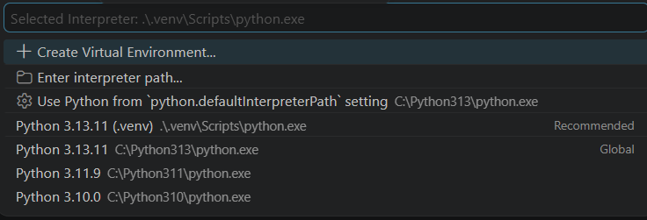
- You are all set

